SCHOOL OF ELECTRICAL ENGINEERING AND COMPUTING

ADAMA SCIENCE AND TECHNOLOGY UNIVERSITY
DEPARTMENT OF SOFTWARE ENGINEERING
Course Title: Component Based Software Development
Course Code: SEng5306

Group Project: Monorepo System Development
1, Dagmawi Adane UGR/26689/14
2, Fitsum Teka UGR/25652/14
3, Yohanan Solomon UGR/25476/14
4, Meriat Akalu UGR/25909/14
5, Hanamariam Mesfin UGR/25483/14

Submitted to: MR. Daniel Metiku

1. Executive Summary
The BizFlow Enterprise System is a modular enterprise platform engineered using a strict monorepo architecture. The system demonstrates how large-scale applications can be decomposed into independent, reusable, and composable feature modules.
Instead of building a single monolithic system, BizFlow is split into:
- Two independent applications
- Ten isolated feature packages
- Two shared foundational libraries
Core Architectural Philosophy
Applications assemble — packages implement.
- Applications contain zero business logic
- Features encapsulate all domain logic
- Shared packages provide pure reusable primitives

2. Architectural Vision
BizFlow is designed around three fundamental principles:
1. Separation of Concerns
- UI, logic, and orchestration are split across layers
2. Reusability over Duplication
- Every feature is written once and reused everywhere
3. Dependency Control
- Strict one-directional dependency flow prevents coupling

3. Group Members and Task Assignment
# | Full Name | Individual Features | Group Contribution
1 | Dagmawi Adane | Inventory, Analytics | Monorepo setup, base UI components
2 | Fitsum Teka | Orders, Payments | UI components (Table, Modal), System A
3 | Yohanan Solomon | Auth, Profile | Utilities, System B
4 | Meriat Akalu | Notifications, Support | Layout, design tokens
5 | Hanamariam Mesfin | Admin, Reporting | Documentation, QA, utilities

4. High-Level Architecture
Three-Layer System Design
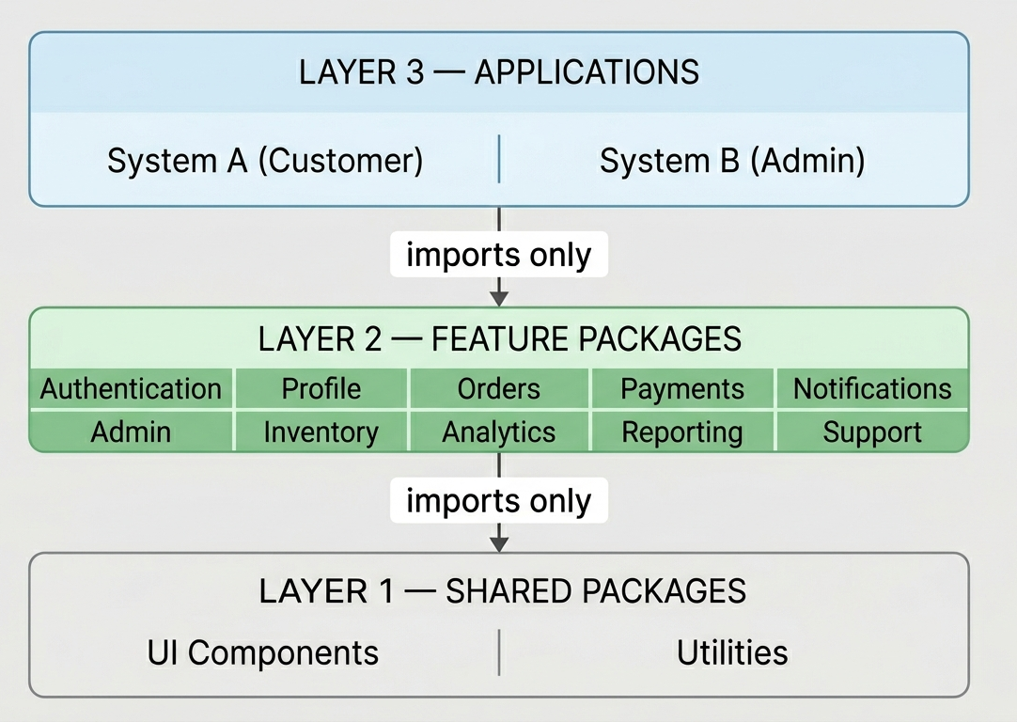

5. Repository Structure

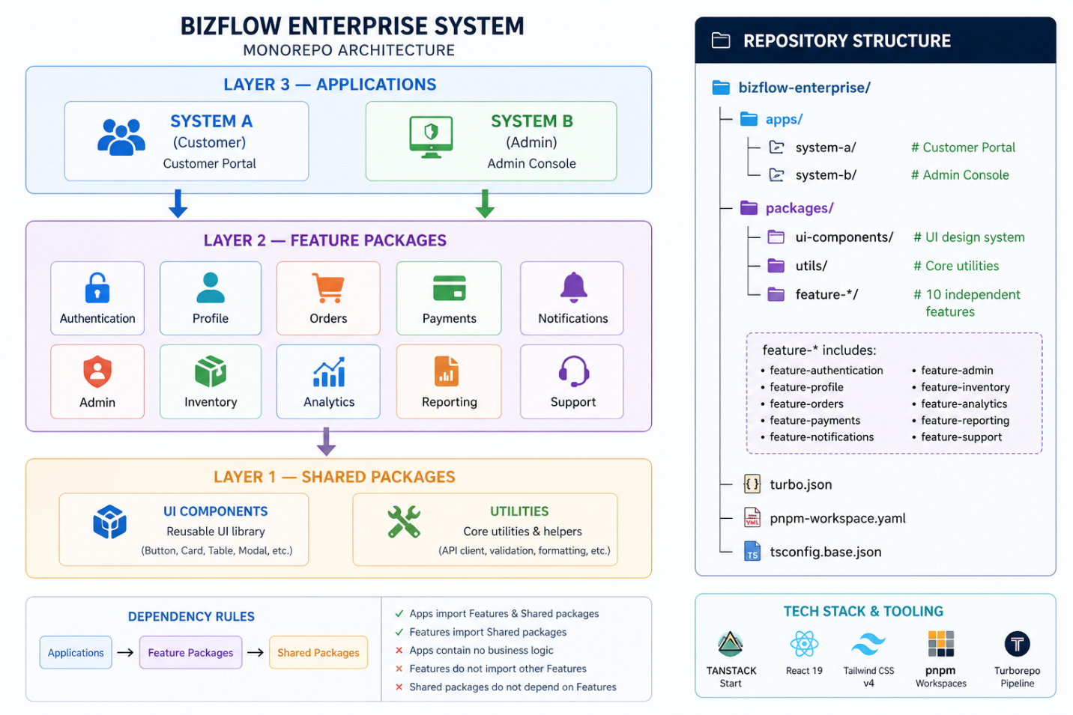6. Layer 1 — Shared Packages

6.1 UI Components (@bizflow/ui-components)
A design system layer providing reusable UI primitives.
Key properties:
- Stateless where possible
- No business logic
- Fully reusable across all features

Example Components:
- Button, Input, Card
- Table, Modal, Badge
- StatCard, PageHeader
- AppShell (layout system)
Design System:
- Built with Tailwind v4
- Uses OKLCH color tokens
- Supports dark/light modes

6.2 Utilities (@bizflow/utils)
A pure logic layer with no UI dependencies.
Responsibilities:
- API abstraction
- Data formatting
- Validation
- Aggregation

Examples:
- apiClient() → centralized HTTP logic
- formatCurrency() → consistent formatting
- validateEmail() → validation logic
- aggregate() → analytics calculations

7. Layer 2 — Feature Packages
Each feature is a self-contained domain module.
Feature Characteristics
- Owns its state
- Owns its API calls
- Owns its UI composition
- Exports public components
Feature List
Feature | Responsibility
Auth | Authentication & sessions
Profile | User account management
Orders | Order lifecycle
Payments | Payment processing
Notifications | Alerts system
Inventory | Stock management
Analytics | KPIs & dashboards
Support | Ticketing system
Admin | User roles & config
Reporting | Reports & exports

8. Layer 3 — Applications
Applications are pure composition layers.
System A — Customer Portal
- Auth
- Profile
- Orders
- Payments
- Notifications
System B — Admin Console
- Auth (reused)
- Inventory
- Analytics
- Support
- Admin
- Reporting

9. Dependency Graph
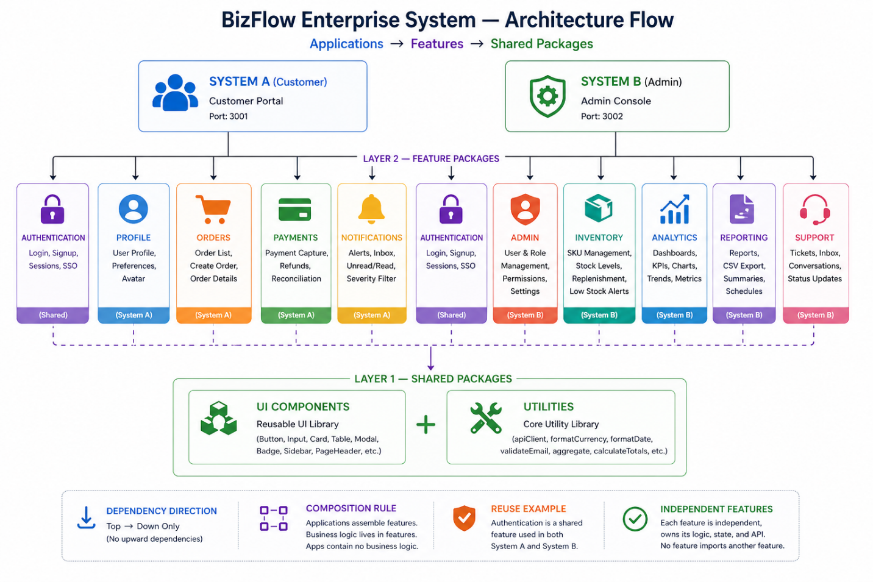

10. Data Flow Architecture
Read Flow
User → App Route → Feature Component → Hook → API Client → Backend
→ Utils (formatting) → UI Components → Render
Write Flow
User Action → Feature Component → Validation (utils)
→ API Client → Backend
→ UI Feedback (shared components)

11. Architectural Advantages
1. True Reusability
- feature-auth reused across both systems without modification
2. Independent Development
- Each developer works on isolated packages
3. Scalability
- New features = new packages (no refactor needed)
4. Maintainability
- Bug fix in one place propagates everywhere
5. Performance
- Turborepo caching reduces build time

12. Anti-Patterns Prevented
This architecture explicitly prevents:
- ❌ Business logic inside apps
- ❌ Tight coupling between features
- ❌ Duplicate implementations
- ❌ Uncontrolled dependencies

13. Quality Assurance Strategy
Layer | Testing Focus
utils | Pure logic correctness
UI | Rendering & accessibility
Features | Behavior & API interactions
Apps | Integration (routing only)

14. Key Architectural Decisions
Decision | Impact
Monorepo over polyrepo | Faster development & integration
Strict layer separation | Clean architecture
Feature isolation | High scalability
Shared design system | UI consistency
Central utilities | Logic reuse

15. Conclusion
The BizFlow Enterprise System successfully demonstrates a production-grade monorepo architecture with:
- Clear separation of layers
- Strong dependency control
- High code reusability
- Scalable feature-based design
Final Insight
BizFlow is not just an application — it is a system architecture blueprint for building scalable enterprise software.

16. References
- TanStack Start
- Turborepo Documentation
- pnpm Workspaces
- Tailwind CSS v4
- ShadCN UI Patterns
- Monorepo Architecture Guides

